Project Design Phase-II
Data Flow Diagram & User Stories

Date | 22 February 2026
Team ID | LTVIP2026TMIDS42582
Project Name | Home-Rentals
Maximum Marks | 4 Marks

Data Flow Diagrams:
A Data Flow Diagram (DFD) is a traditional visual representation of the information flows within a system. A neat and clear DFD can depict the right amount of the system requirement graphically. It shows how data enters and leaves the system, what changes the information, and where data is stored.

Example: (Simplified)
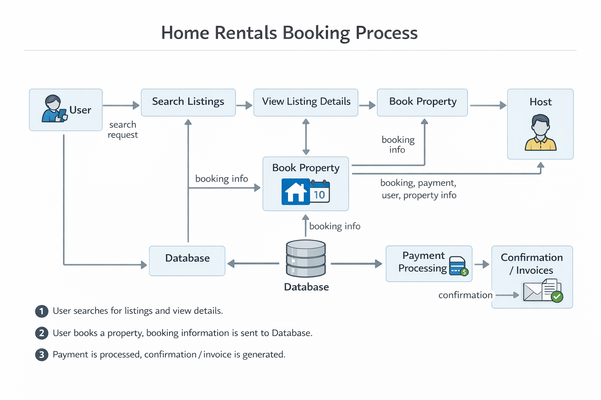

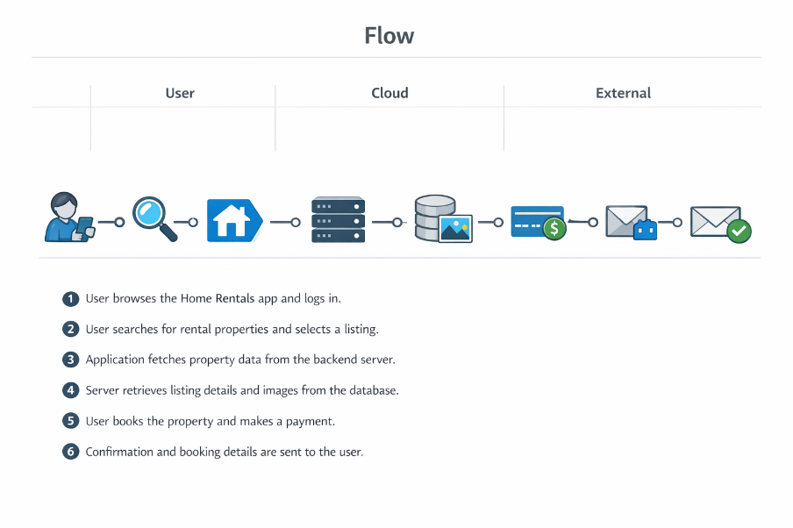

User Stories
Use the below template to list all the user stories for the product.
User Type | Functional Requirement (Epic) | User Story Number | User Story / Task | Acceptance criteria | Priority | Release
Customer (Mobile user) | Registration | USN-1 | As a user, I can register for the application by entering my email, password, and confirming my password. | I can access my account / dashboard | High | Sprint-1
 | Registration | USN-2 | As a user, I will receive confirmation email once I have registered for the application | I can receive confirmation email & click confirm | High | Sprint-1
 | Registration | USN-3 | As a user, I can register for the application through Facebook | I can register & access the dashboard with Facebook Login | Low | Sprint-2
 | Registration | USN-4 | As a user, I can register for the application through Gmail | I can register and access dashboard with Google login. | Medium | Sprint-1
 | Login | USN-5 | As a user, I can log into the application by entering email & password | I can log in and access my dashboard. | High | Sprint -1
 | Search Listings | USN-6 | As a user, I can search for rental properties by location, date, and price. | I see relevant listings based on my search criteria. | High | Sprint - 1
Customer (Web user) | Registration/Login | USN-11 | As a web user, I can register and log in via the website. | I can access my account/dashboard on the web. | High | Sprint - 1
Customer Care Executive | Support | USN-14 | As a support agent, I can view user issues and respond to queries. | I can resolve or escalate user issues. | Medium | Sprint - 3
Administrator | User Management | USN-15 | As an admin, I can manage users, listings, and bookings. | I can view, edit, or remove users and listings. | High | Sprint - 3
 | Analytics | USN-16 | As an admin, I can view analytics on bookings and users. | I see reports and statistics in the admin dashboard. | Medium | Sprint - 3

